Tamasoma Jythorgamaya | SETH GHASIRAM GOPIKISHAN BADRUKA EDUCATIONAL SOCIETY  Station Road, Kachiguda, Hyderabad 500 027 | 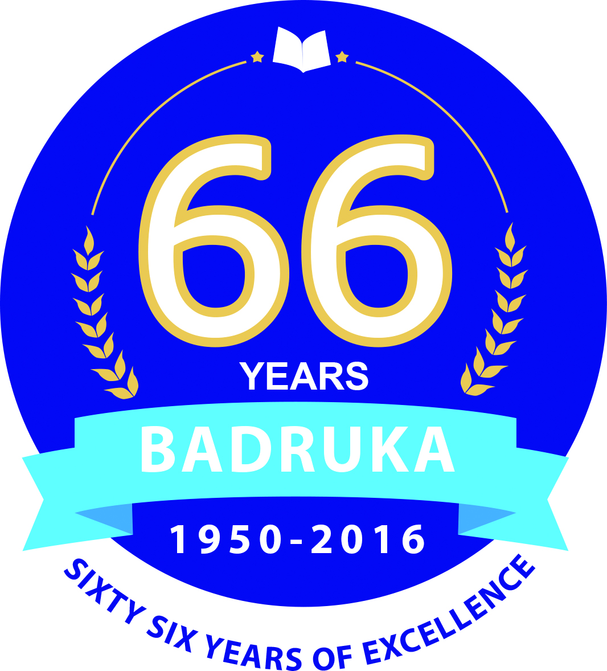

SGGBES Proposes to recruit the following personnel for their colleges

- Badruka College of Commerce & Arts
- Bankatlal Badruka College of Information Technology
- Badruka College – Post Graduate Centre &
- Badruka Junior College for Girls

- ASSISTANT PROFESSORS

in Commerce, Mathematics, Statistics, Electronics, HR,
Marketing, Finance, English and Sanskrit

Qualifications : Candidates must have minimum 55% of marks in PG in concerned subject;

Preference will be given to candidates with Ph.D/NET/SLET and experience.

- JUNIOR LECTURERS

in Commerce, Economics, Mathematics, Civics, English, Sanskrit
and Hindi.

Qualifications : Candidates must have minimum 55% of marks in PG in concerned subject; candidates with experience are preferred.

- Non Teaching Staff

Administrative Officer : Graduate in any discipline; shall have good knowledge of University, UGC & AICTE Guidelines, and should have worked in similar position in any reputed educational institute.

Junior Assistant : Graduate in any discipline. Good in office administration and correspondence with knowledge in computer applications.

Steno-cum-clerk : Candidates having senior stenography, knowledge of MS Office, E-mail Management and Office Management.

Librarian : Candidates with M.Lib. & I.Sc., and knowledge in library management.

Library Assistant : Candidates should have degree in library science.

Computer Lab Assistants – Candidates with Diploma in Computer Science.

Candidates may submit their CVs in hard and soft copies
along with certificates of qualifications and experience
on or before 25th May 2017 to :

Director General
Badruka Educational Society
Station Road, Kachiguda,
Hyderabad 500 027.

Email: dg@badruka.com

